Design Document
October 2nd, 2018

OBJECTIVE
To provide users a loading screen while during their Spotify searches and playlist updates. This will give users feedback that the app is working rather than the impression that nothing is happening.

BACKGROUND
The first impression provided by an app is extremely important. So too is the feedback that an app provided as it is being used. It is important not to underestimates how first impressions impact upon the success of an app; which is just an important for Jamming as for other web apps.
Jamming provides is an app that provides a platform for users to search for their preferred artists, albums and tracks. Once users find their preferred artists, albums and tracks they will then be updating their Spotify playlists. Updating a playlist involves using the appropriate Spotify APIs which involves the users’ preferred browser, internet connection and Spotify web infrastructure. Naturally, these have implications for users’ experience of Jamming.
These influences may mean that Jamming may not provide a consistent user experience all the time. For example, a slow internet connection may mean that Jamming appears unresponsive while searching Spotify for artists, albums and tracks. Therefore, it is important to provide feedback to the user as Jamming’s background processes are running.
Maile Ohye from Google notes the following ‘two seconds is the threshold for … website acceptability … At Google, we aim for under a half second.’ While this quote is in the context of an ecommerce website it still has implications for other non-ecommerce websites, such as Jamming. So, a site that is performing well will provide a better user experience than a slow site which may give a user a bad experience.
Don Purdum (Lead Marketing Consultant) notes that most end users will not know what is happening in the background while a page loads or updates. Jamming is downloading and updating JSON data as a user interacts with it. Don Purdum mentions that the user may assume there is a problem with the website and therefore get a negative impression of Jamming.
Naturally, Jamming will coexist in the users’ wider internet ecosystem that includes social media. If Jamming gave the impression of being slow then there is the added risk of that impression being magnified exponentially.
The loading screen will need the following functionality:
- The loading screen will appear to the user when the ‘SEARCH’ and ‘SAVE TO SPOTIFY’ buttons are clicked.
- The loading screen will be an animation that shows regular movement in a predefined manner.
- The loading screen will disappear once the search music information is downloaded from Spotify or the playlist is updated with the search results.

TECHNICAL DESIGN
The design of the loading screen will require React, JSX and CSS.
The loader screen will be a React component that renders JSX to create the loading screen visuals. The following component is used to create the loader screen:
<LoadingScreen message={this.state.message} />

Where {this.state.message} is the message that appears on the loading screen.
The LoadingScreen class is defined as follows:
import React from 'react';
import './LoadingScreen.css';
class LoadingScreen extends React.Component {
constructor(props) {
super(props);
this.state = {
processingLogonMessage = ‘ ’,
};
}
render() {
return(
<div className=’loading-screen>
<div className=’loading’>
<span className=’message’ >
${this.state. processingLogonMessage}
</span>
</div>
</div>
);
}
}
export default LoadingScreen;

This React component would be called when the user clicks on the SEARCH and SAVE TO SPOTIFY buttons. Once the asynchronous downloads and uploads are completed the React component would be removed. The following stackoverflow.com article is one way this could be done:
https://stackoverflow.com/questions/27227792/react-js-removing-a-component
In addition, there will be the following CSS file:
Loading-screen.css
.loading-screen {
background-color: rgba(1, 12, 63, 0.7);
border-radius: 10px;
box-shadow: 0 4px 2px 2px #000000;
font-family: arial, sans-serif;
display: flex;
flex-direction: column;
align-items: center;
justify-content: center;
height: 150px;
width: 120px;
}

.loading {
border: 16px solid #f3f3f3;
border-radius: 50%;
border-top: 16px solid #6c41ec;
width: 60px;
height: 60px;
-webkit-animation: spin 2s linear infinite; /* Safari */
animation: spin 2s linear infinite;
}

.message {
background-color: #6c41ec;
border: 1px none;
border-radius: 10px;
color: rgba(256, 256, 256, 0.8);
margin-top: 10px;
padding: 5px;
}

/* Safari */
@-webkit-keyframes spin {
0% { -webkit-transform: rotate(0deg); }
100% { -webkit-transform: rotate(360deg); }
}

@keyframes spin {
0% { transform: rotate(0deg); }
100% { transform: rotate(360deg); }
}

The React component will look like the following wireframe:
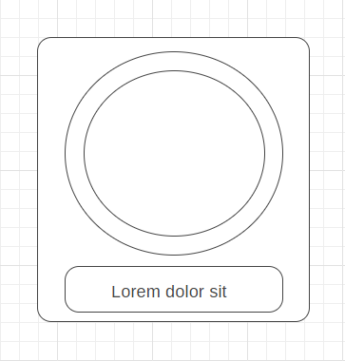

There will be a circular animation within a rounded square background. The two circles represent the circular movement within the two lines. The smaller rounded box with the text indicates the message that will appear after a set number of seconds advising that the accessing the Spotify API is taking longer than expected.
In the context of the wider screen it will appear like this.
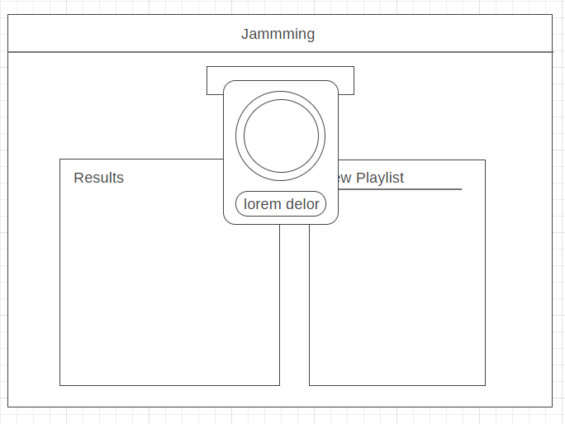

The final loading screen would look like the following (note: the coloured bar in the circle will spin).
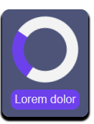

CAVEATS
One alternative to the loading screen is to do nothing and leave Jamming as it is. If the user’s internet connection is fast enough then any delay caused by searching for music or updating playlists may be negligible.
Another alternative would be to use a Bootstrap alert rather than a loading screen. Bootstrap provides several alerts, which includes the following categories:
- Success
- Danger
- Info
These alerts can also be interactive so when the user clicks on the ‘X’ on the right hand side of the alert it disappears. So, in the case of LoadingScreen a Bootstrap alert could be used instead; the alert could be a Bootstrap Info alert that the user clicks on to close. Thereby giving the user feedback and interactively with Jamming while waiting for the JSON data to download / upload asynchronously in the background.
While both alternatives could be considered viable to LoadingScreen, the use of a loading screen has a better visual appeal and conveys to the user that Jamming is still working in the background.

BIBLIOGRAPHY
https://www.mobiloud.com/blog/mobile-app-launch-screen-examples/
https://www.hobo-web.co.uk/your-website-design-should-load-in-4-seconds/
https://ihatetomatoes.net/create-custom-preloading-screen/
https://youtu.be/jwfM38gnHGM
https://developer.mozilla.org/en-US/docs/Web/CSS/CSS_Animations/Using_CSS_animations
https://wireframe.cc/

